**WEEK - 4**

**Spring Rest**

**Mandatory**

1. **Create a Spring Web Project using Maven**

**SpringLearnApplication.java**

package com.cognizant.spring_learn;

import org.springframework.boot.SpringApplication;

import org.springframework.boot.autoconfigure.SpringBootApplication;

import org.slf4j.Logger;

import org.slf4j.LoggerFactory;

@SpringBootApplication

public class SpringLearnApplication {

private static final Logger LOGGER = LoggerFactory.getLogger(SpringLearnApplication.class);

public static void main(String[] args) {

SpringApplication.run(SpringLearnApplication.class, args);

LOGGER.info("Inside main");

}

}

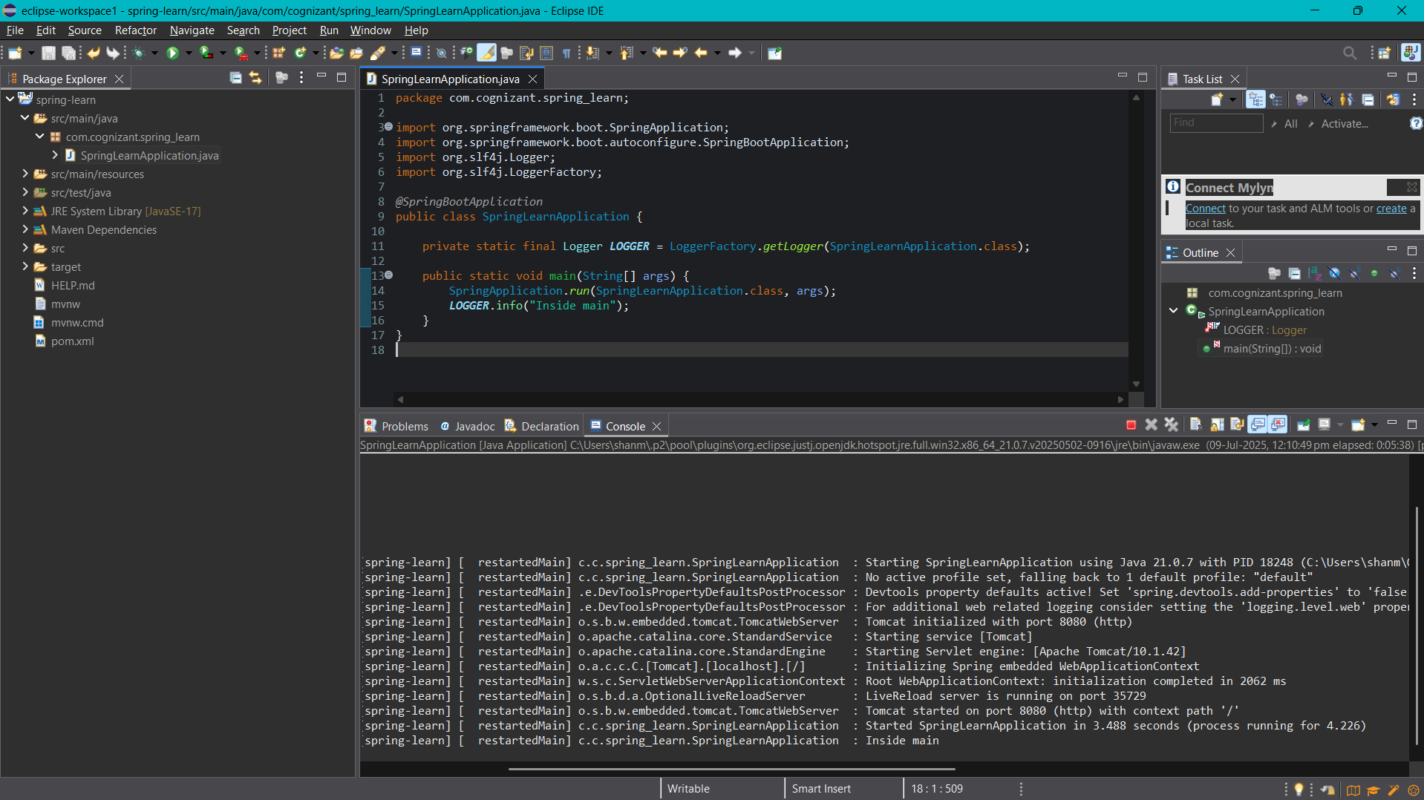

1. **Spring Core – Load Country from Spring Configuration XML**

**Country.xml**

<?xml version="1.0" encoding="UTF-8"?>

<beans xmlns="http://www.springframework.org/schema/beans"

xmlns:xsi="http://www.w3.org/2001/XMLSchema-instance"

xsi:schemaLocation="http://www.springframework.org/schema/beans

https://www.springframework.org/schema/beans/spring-beans.xsd">

<bean id="country" class="com.cognizant.spring_learn.Country">

<property name="code" value="IN"/>

<property name="name" value="India"/>

</bean>

</beans>

**Country.java**

package com.cognizant.spring_learn;

import org.slf4j.Logger;

import org.slf4j.LoggerFactory;

public class Country {

private static final Logger LOGGER = LoggerFactory.getLogger(Country.class);

private String code;

private String name;

public Country() {

LOGGER.debug("Inside Country Constructor.");

}

public String getCode() {

LOGGER.debug("Inside getCode()");

return code;

}

public void setCode(String code) {

LOGGER.debug("Inside setCode()");

this.code = code;

}

public String getName() {

LOGGER.debug("Inside getName()");

return name;

}

public void setName(String name) {

LOGGER.debug("Inside setName()");

this.name = name;

}

@Override

public String toString() {

return "Country [code=" + code + ", name=" + name + "]";

}

}

**SpringLearnApplication.java**

package com.cognizant.spring_learn;

import com.cognizant.spring_learn.Country;

import org.slf4j.Logger;

import org.slf4j.LoggerFactory;

import org.springframework.context.ApplicationContext;

import org.springframework.context.support.ClassPathXmlApplicationContext;

public class SpringLearnApplication {

private static final Logger LOGGER = LoggerFactory.getLogger(SpringLearnApplication.class);

public static void main(String[] args) {

LOGGER.info("START");

displayCountry();

LOGGER.info("END");

}

public static void displayCountry() {

ApplicationContext context = new ClassPathXmlApplicationContext("country.xml");

Country country = context.getBean("country", Country.class);

LOGGER.debug("Country : {}", country.toString());

}

}

**Logback.xml**

<configuration>

<appender name="STDOUT" class="ch.qos.logback.core.ConsoleAppender">

<encoder>

<pattern>%d{HH:mm:ss.SSS} [%thread] %-5level %logger{36} - %msg%n</pattern>

</encoder>

</appender>

<logger name="com.cognizant" level="DEBUG"/>

<root level="INFO">

<appender-ref ref="STDOUT" />

</root>

</configuration>

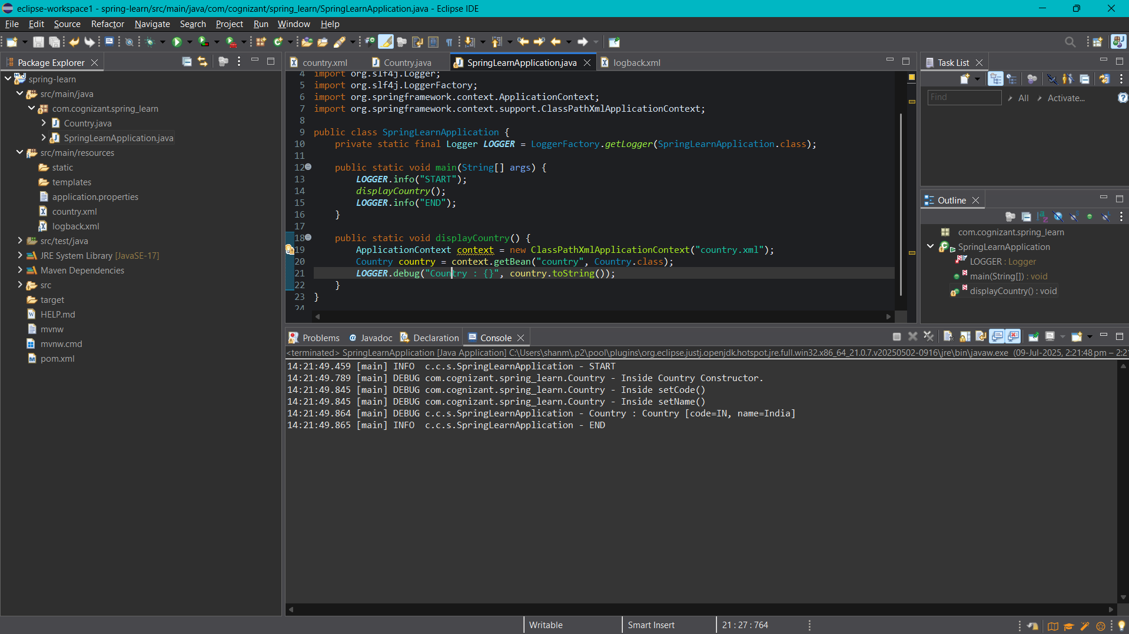

1. **Hello World RESTful Web Service**

**Pom.xml**

<dependency>

<groupId>org.springframework.boot</groupId>

<artifactId>spring-boot-starter-web</artifactId>

</dependency>

**application.properties**

spring.application.name=spring-learn

**HelloController.java**

package com.cognizant.spring_learn.controller;

import org.slf4j.Logger;

import org.slf4j.LoggerFactory;

import org.springframework.web.bind.annotation.GetMapping;

import org.springframework.web.bind.annotation.RestController;

@RestController

public class HelloController {

private static final Logger LOGGER = LoggerFactory.getLogger(HelloController.class);

@GetMapping("/hello")

public String sayHello() {

LOGGER.info("START");

LOGGER.info("END");

return "Hello World!!";

}

}

**SpringLearnApplication.java**

package com.cognizant.spring_learn;

import org.slf4j.Logger;

import org.slf4j.LoggerFactory;

import org.springframework.boot.SpringApplication;

import org.springframework.boot.autoconfigure.SpringBootApplication;

@SpringBootApplication

public class SpringLearnApplication {

private static final Logger LOGGER = LoggerFactory.getLogger(SpringLearnApplication.class);

public static void main(String[] args) {

LOGGER.info("START");

SpringApplication.run(SpringLearnApplication.class, args);

LOGGER.info("END");

}

}

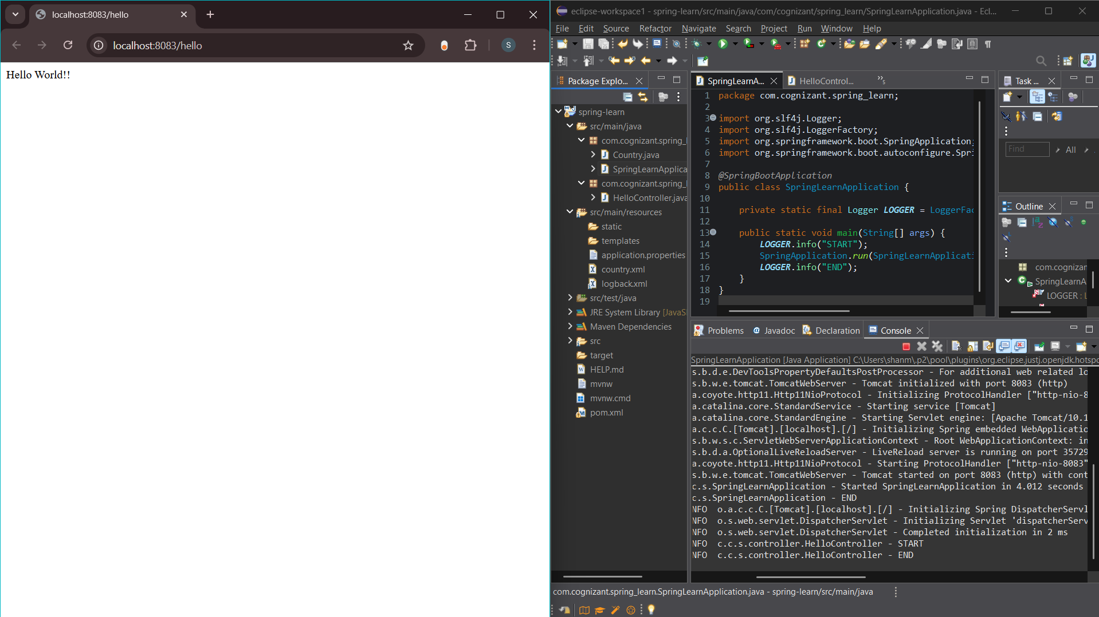

1. **REST - Country Web Service**

**Country.java**

package com.cognizant.spring_learn;

import org.slf4j.Logger;

import org.slf4j.LoggerFactory;

public class Country {

private static final Logger LOGGER = LoggerFactory.getLogger(Country.class);

private String code;

private String name;

public Country() {

LOGGER.debug("Inside Country Constructor.");

}

public String getCode() {

LOGGER.debug("Getting code: {}", code);

return code;

}

public void setCode(String code) {

LOGGER.debug("Setting code: {}", code);

this.code = code;

}

public String getName() {

LOGGER.debug("Getting name: {}", name);

return name;

}

public void setName(String name) {

LOGGER.debug("Setting name: {}", name);

this.name = name;

}

@Override

public String toString() {

return "Country [code=" + code + ", name=" + name + "]";

}

}

**Country.xml**

<?xml version="1.0" encoding="UTF-8"?>

<beans xmlns="http://www.springframework.org/schema/beans"

xmlns:xsi="http://www.w3.org/2001/XMLSchema-instance"

xsi:schemaLocation="http://www.springframework.org/schema/beans

https://www.springframework.org/schema/beans/spring-beans.xsd">

<bean id="country" class="com.cognizant.spring_learn.Country">

<property name="code" value="IN" />

<property name="name" value="India" />

</bean>

</beans>

**CountryController.java**

package com.cognizant.spring_learn.controller;

import com.cognizant.spring_learn.Country;

import org.slf4j.Logger;

import org.slf4j.LoggerFactory;

import org.springframework.web.bind.annotation.RestController;

import org.springframework.web.bind.annotation.RequestMapping;

import org.springframework.context.ApplicationContext;

import org.springframework.context.support.ClassPathXmlApplicationContext;

@RestController

public class CountryController {

private static final Logger LOGGER = LoggerFactory.getLogger(CountryController.class);

@RequestMapping("/country")

public Country getCountryIndia() {

LOGGER.info("START");

ApplicationContext context = new ClassPathXmlApplicationContext("country.xml");

Country country = context.getBean("country", Country.class);

LOGGER.info("END");

return country;

}

}

**SpringLearnApplication.java**

package com.cognizant.spring_learn;

import org.slf4j.Logger;

import org.slf4j.LoggerFactory;

import org.springframework.boot.SpringApplication;

import org.springframework.boot.autoconfigure.SpringBootApplication;

@SpringBootApplication

public class SpringLearnApplication {

private static final Logger LOGGER = LoggerFactory.getLogger(SpringLearnApplication.class);

public static void main(String[] args) {

LOGGER.info("START");

SpringApplication.run(SpringLearnApplication.class, args);

LOGGER.info("END");

}

}

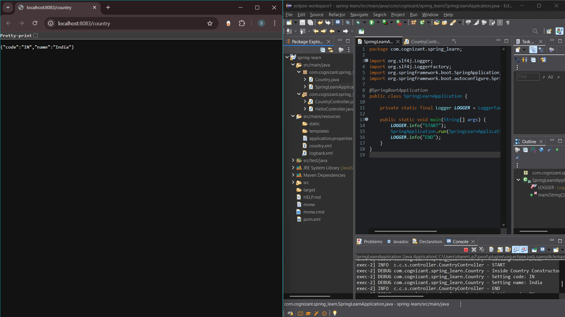

1. **REST - Get country based on country code**

**Country.xml**

<?xml version="1.0" encoding="UTF-8"?>

<beans xmlns="http://www.springframework.org/schema/beans"

xmlns:xsi="http://www.w3.org/2001/XMLSchema-instance"

xsi:schemaLocation="http://www.springframework.org/schema/beans

https://www.springframework.org/schema/beans/spring-beans.xsd">

<bean id="countryList" class="java.util.ArrayList">

<constructor-arg>

<list>

<bean class="com.cognizant.spring_learn.Country">

<property name="code" value="IN" />

<property name="name" value="India" />

</bean>

<bean class="com.cognizant.spring_learn.Country">

<property name="code" value="US" />

<property name="name" value="United States" />

</bean>

<bean class="com.cognizant.spring_learn.Country">

<property name="code" value="JP" />

<property name="name" value="Japan" />

</bean>

<bean class="com.cognizant.spring_learn.Country">

<property name="code" value="DE" />

<property name="name" value="Germany" />

</bean>

</list>

</constructor-arg>

</bean>

</beans>

**Application.properties**

spring.application.name=spring-learn

server.port=8083

logging.level.root=INFO

**Country.java**

package com.cognizant.spring_learn;

import org.slf4j.Logger;

import org.slf4j.LoggerFactory;

public class Country {

private static final Logger LOGGER = LoggerFactory.getLogger(Country.class);

private String code;

private String name;

public Country() {

LOGGER.debug("Inside Country Constructor.");

}

public String getCode() {

LOGGER.debug("Inside getCode()");

return code;

}

public void setCode(String code) {

LOGGER.debug("Inside setCode()");

this.code = code;

}

public String getName() {

LOGGER.debug("Inside getName()");

return name;

}

public void setName(String name) {

LOGGER.debug("Inside setName()");

this.name = name;

}

@Override

public String toString() {

return "Country [code=" + code + ", name=" + name + "]";

}

}

**CountryController.java**

package com.cognizant.spring_learn.controller;

import org.slf4j.Logger;

import org.slf4j.LoggerFactory;

import org.springframework.beans.factory.annotation.Autowired;

import org.springframework.web.bind.annotation.*;

import com.cognizant.spring_learn.Country;

import com.cognizant.spring_learn.service.CountryService;

@RestController

public class CountryController {

private static final Logger LOGGER = LoggerFactory.getLogger(CountryController.class);

@Autowired

private CountryService countryService;

@GetMapping("/countries/{code}")

public Country getCountry(@PathVariable String code) {

LOGGER.info("START: getCountry()");

Country country = countryService.getCountry(code);

LOGGER.info("END: getCountry()");

return country;

}

}

**CountryService.java**

package com.cognizant.spring_learn.service;

import java.util.List;

import java.util.Optional;

import org.slf4j.Logger;

import org.slf4j.LoggerFactory;

import org.springframework.context.ApplicationContext;

import org.springframework.context.support.ClassPathXmlApplicationContext;

import org.springframework.stereotype.Service;

import com.cognizant.spring_learn.Country;

@Service

public class CountryService {

private static final Logger LOGGER = LoggerFactory.getLogger(CountryService.class);

public Country getCountry(String code) {

LOGGER.info("START: getCountry()");

ApplicationContext context = new ClassPathXmlApplicationContext("country.xml");

List<Country> countryList = (List<Country>) context.getBean("countryList");

Optional<Country> country = countryList.stream()

.filter(c -> c.getCode().equalsIgnoreCase(code))

.findFirst();

LOGGER.info("END: getCountry()");

return country.orElse(null); // or throw a custom exception

}

}

**SpringLearnApplication.java**

package com.cognizant.spring_learn;

import org.slf4j.Logger;

import org.slf4j.LoggerFactory;

import org.springframework.boot.SpringApplication;

import org.springframework.boot.autoconfigure.SpringBootApplication;

@SpringBootApplication

public class SpringLearnApplication {

private static final Logger LOGGER = LoggerFactory.getLogger(SpringLearnApplication.class);

public static void main(String[] args) {

LOGGER.info("START");

SpringApplication.run(SpringLearnApplication.class, args);

LOGGER.info("END");

}

}

